EPAM University Programs

DevOps external course

Module 4 Linux & Bash Essentials

TASK 4.5

*Mariia Markina*

1. To discover files with active sticky bits, use the following version of the find command:

sudo find / -perm /6000 -type f -exec ls -ld {} \;>setuid.txt

Put into your report a fragment of setuid.txt file. Explain meaning of parameters of the above find command (hint: use find’s man page).

We are finding files (-type f) in a root directory (/), that have no permissions to read, write and execute either for user, or for group user, or other (only for owner or owner`s group) (-perm /6000). Then we are executing command large ls for found directory (-exec ls -ld {}, where {} – found directory). After that, writing the results into setuid.txt (>setuid.txt).



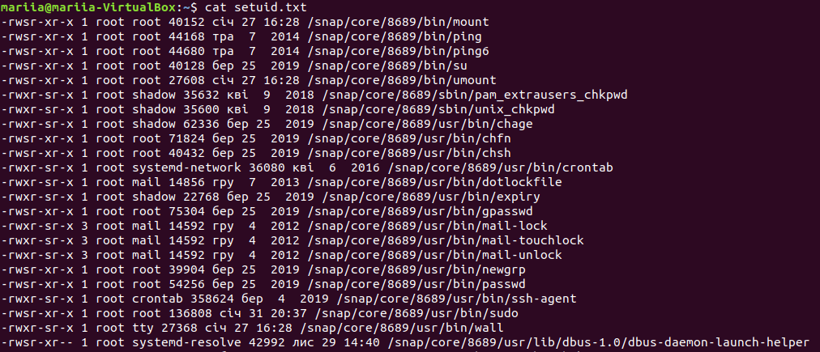

2. Discovering soft and hard links.

Comment on results of these commands (place the output into your report):   
cd

mkdir test

cd test

touch test1.txt

echo “test1.txt” > test1.txt

ls -l .

(a hard link)

ln test1.txt test2.txt

ls -l .

cd takes us to the home directory, then we are making there a new directory test and creating there test1.txt file. Then, writing out “test1.txt” in this file. Now, there is this file in test directory. After this, creating a new hard link test2.txt (which refers to test1.), as we can see, it looks exactly like the original file, number of links – 2 for both files.

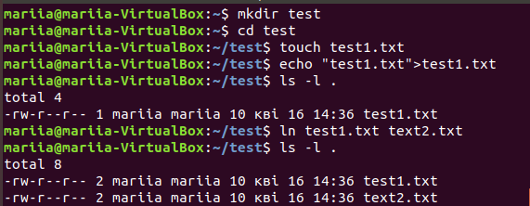

(pay attention to the number of links to test1.txt and test2.txt)

echo “test2.txt” > test2.txt

cat test1.txt test2.txt

rm test1.txt

ls -l .

(now a soft link)

ln -s test2.txt test3.txt

ls -l .

(pay attention to the number of links to the created files)

rm test2.txt; ls -l .

Writing “test2.txt” to the test2.txt file and now, as we can see, in both files “test2.txt” is written (so, file changes if it`s hard link file is changed) and removing first file. Creating a soft link file test3.txt, which refers to test2.txt. Number of files is 1 for both files. After removal of the original file in ls we can see that soft link is still there, but something is wrong with it and it cannot be read (because file is deleted).

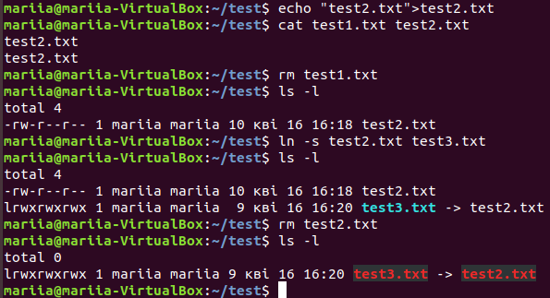

3. I/O redirect.

Execute these commands; comment on the output.

mount – shows data about file system.

blkid – shows information about devices.

mount | grep sda – shows only that information about file system, which refers to sda (hard disk).

dmesg | grep sda -shows messages about devices, detected by kernel, in this case messages about sda (grep sda). 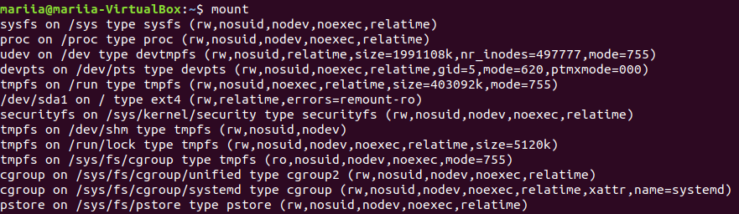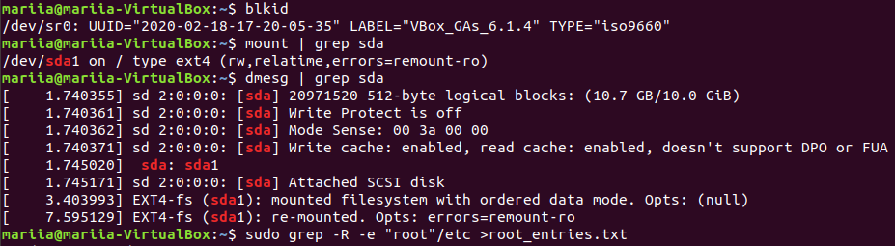

sudo grep -R -e “root” /etc > root_entries.txt – shows all entries of text “root” in directory /etc, checking also symlinks(-R) and putting output in root_entries.txt file.

(place only a reasonable fragment of root_entries.txt into your report)

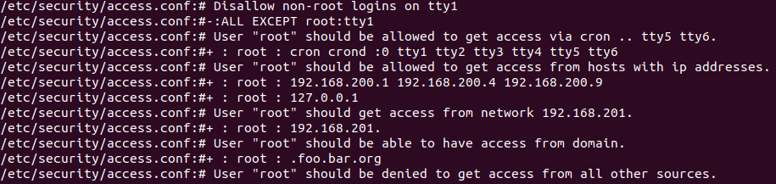

Here we can see permissions and privileges of the root user, for example, what tty can be used.